BRAIN TUMOR DETECTION
A Capstone Project Report

Submitted by
DHRUV PAHAL | 20231BCA0260
VIKAS V | 20231BCA0262
BHARGAV DEEKSHITH | 20231BCA0250
VAISHNAVI SATISH | 20231BCA0267

Under the guidance of
Dr. Raja Jitendra Nayaka
Assistant professor Selection Grade
in partial fulfillment for the award of the degree of

BACHELOR OF COMPUTER APPLICATIONS
At



SCHOOL OF INFORMATION SCIENCE
PRESIDENCY UNIVERSITY
BENGALURU

MAY 2025

BACHELOR OF COMPUTER APPLICATIONS

SCHOOL OF INFORMATION SCIENCE

PRESIDENCY UNIVERSITY

CERTIFICATE

This is to certified that the Capstone Project report “Brain Tumor Detection” being submitted by DHRUV PAHAL, VIKAS V, BHARGAV DEEKSHITH, VAISHNAVI SATISH bearing roll number 20231BCA0260, 20231BCA0262, 20231BCA0250, 20231BCA0267 in partial fulfillment of requirement for the award of degree of Bachelor of Computer Applications is a bonafide work carried out under my supervision.

____________________  Dr. Raja Jitendra Nayaka  Assistant professor  Selection Grade  Presidency University | _______________  Dr. Vetrimani Elangovan  Head of the Department (PSIS),  Presidency School of IS  Presidency University
__  Dr. R Mahalakshmi  Associate Dean,  Presidency School of IS  Presidency University | __________  Dr. Md. Sameeruddin Khan  Dean,  Presidency School of CSE&IS  Presidency University

ABSTRACT

This project presents the design and implementation of a brain tumor detection system using deep learning techniques, specifically applied to MRI (Magnetic Resonance Imaging) scans. With the increasing demand for rapid and accurate diagnostic tools in the medical field, this system aims to assist radiologists and healthcare professionals in the early detection of brain tumors. The project utilizes a Convolutional Neural Network (CNN), a deep learning model well-suited for image classification tasks due to its ability to automatically extract spatial hierarchies of features from input images. A publicly available dataset of brain MRI images is used, comprising both tumor and non-tumor cases, ensuring the model is trained on diverse and balanced data.
The system is developed using Python and several open-source libraries, including TensorFlow, Keras, NumPy, and Matplotlib, which collectively support data preprocessing, model building, training, testing, and visualization. The dataset is first preprocessed to normalize image sizes and enhance contrast, followed by data augmentation techniques to improve model generalization and prevent overfitting. The CNN architecture includes multiple convolutional layers, pooling layers, and fully connected layers, optimized through techniques such as dropout and activation functions. The model achieves high accuracy in classifying MRI images, with performance metrics such as precision, recall, and F1-score used to evaluate its effectiveness.
This project demonstrates how artificial intelligence and computer vision can be harnessed to address real-world challenges in healthcare. By automating the process of tumor detection, the proposed system reduces diagnostic time, minimizes human error, and provides a cost-effective solution for resource-limited settings. It also highlights the growing role of deep learning in biomedical applications and offers a foundation for further research into multi-class classification of different tumor types or integration into real-time diagnostic systems.

ACKNOWLEDGMENT

The completion of project work brings with great sense of satisfaction, but it is never completed without thanking the persons who are all responsible for its successful completion. First and foremost we indebted to the GOD ALMIGHTY for giving us the opportunity to excel our efforts to complete this project on time. We wish to express our deep sincere feelings of gratitude to our Institution, Presidency University, for providing us opportunity to do our education.
We express our sincere thanks to our respected dean Dr. Md. Sameeruddin Khan, Pro-Vice Chancellor, School of Engineering, and Dean, Presidency School of CSE and IS, Presidency University for getting us permission to undergo the project.
We record our heartfelt gratitude to our beloved professor Dr. R Mahalakshmi, Associate Dean, Presidency School of Information Science, Dr. Vetrimani Elangovan, Assistant Professor – Senior Scale and Head, Presidency School of Information Science, Presidency University for rendering timely help for the successful completion of this project.
We sincerely thank our project guide, Dr. Raja Jitendra Nayaka, Assistant Professor, Selection Grade, for his guidance, help and motivation. Apart from the area of work, we learnt a lot from him, which we are sure will be useful in different stages of our life. We would like to express our gratitude to Faculty Coordinators and Faculty, for their review and many helpful comments.

Lastly, We would like to acknowledge the support and encouragement of our friends.

Student Name | ID Number
DHRUV PAHAL | 20231BCA0260
VIKAS V | 20231BCA0262
BHARGAV DEEKSHITH | 20231BCA0250
VAISHNAVI SATISH | 20231BCA0267

TABLE OF CONTENTS

Chapter No. | Topic Name | Page No.
1 | Introduction | 7-12
2 | Literature Survey | 13-17
3 | Proposed Method | 18-19
4 | Objectives | 20
5 | Methodology | 21-31
6 | Outcomes | 32-33
7 | Results and Discussion | 34-37
8 | Conclusion | 38-39
9 | References | 40-41
10 | Annexure | 42-47

LIST OF FIGURES
Figure No | Caption | Page No.
1.1 | Pituitary Brain Tumor | 9
1.2 | Glioma Brain Tumor | 9
1.3 | Meningioma Brain Tumor | 10
1.4 | No Tumor Brain Tumor | 10
5.1 | Input Images | 23
5.2 | No Brain Tumor(OUTPUT) | 24
5.3 | Pituitary Brain Tumor(OUTPUT) | 25
5.4 | Glioma Brain Tumor(OUTPUT) | 26
5.5 | Meningioma Brain Tumor(OUTPUT) | 27
5.6 | Model Training(Source Code) | 42-45
5.7 | Backend(Source Code) | 46
5.8 | Frontend(Source Code) | 47

LIST OF TABLES
Table No | Caption | Page No.
2.1 | Literature Survey | 16-17

CHAPTER-1
INTRODUCTION
Brain tumors are among the most critical and life-threatening conditions in modern medicine. These abnormal growths of cells in the brain can be either malignant (cancerous) or benign (non-cancerous), but in either case, their presence can severely affect the brain's functionality, leading to a wide range of neurological disorders or even death if not detected early. Early and accurate detection of brain tumors is crucial for effective treatment planning and increasing the chances of patient survival. However, conventional methods of tumor diagnosis, such as manual inspection of MRI (Magnetic Resonance Imaging) scans by radiologists, are often time-consuming, error-prone, and highly dependent on the expertise of the medical professional. In this context, integrating artificial intelligence (AI), particularly deep learning, into medical imaging has become an emerging area of interest due to its potential to enhance diagnostic accuracy and efficiency.
Magnetic Resonance Imaging is a widely used, non-invasive medical imaging technique that produces high-resolution images of the brain’s internal structure. Due to its ability to distinguish soft tissues clearly, MRI is especially valuable in detecting abnormalities such as tumors. However, analyzing these MRI images manually for identifying tumors involves challenges such as visual ambiguity, overlapping features, and inter-observer variability. This motivates the development of automated systems that can support or assist medical professionals in interpreting MRI scans more reliably. With the advent of machine learning and deep learning technologies, particularly Convolutional Neural Networks (CNNs), it has become feasible to build systems capable of learning patterns directly from medical images and making accurate predictions.
In this project, a deep learning-based approach is implemented to detect the presence of brain tumors using MRI image data. A Convolutional Neural Network is trained to classify MRI scans into four categories: pituitary tumor, glioma tumor, meningioma tumor and notumor. CNNs are especially well-suited for this task because they automatically learn spatial hierarchies of features through multiple layers of filters, pooling, and non-linear transformations. Unlike traditional machine learning models that require manual feature extraction, CNNs eliminate this step, resulting in a more streamlined and effective image classification process. The dataset used for this project comprises a large number of MRI images labelled accordingly, ensuring that the model learns from diverse examples and can generalize well to unseen data.

The project is developed using Python, along with essential libraries and frameworks such as TensorFlow, Keras, NumPy, OpenCV, and Matplotlib. These tools are instrumental in building, training, evaluating, and visualizing the performance of the specific VGG16 of CNN model. The dataset is preprocessed by resizing images, converting them to grayscale or RGB as required, normalizing pixel values, and performing data augmentation to artificially expand the dataset. These steps enhance the robustness of the model and prevent overfitting. The model architecture consists of several convolutional and max-pooling layers, followed by fully connected layers and output neurons with Softmax activation to produce binary classification results. The training process involves the optimization of parameters using techniques such as backpropagation and gradient descent, with evaluation metrics including accuracy, precision, recall, and F1-score.
This project aims not only to build an accurate detection model but also to explore the real-world applicability of deep learning in healthcare. By creating an automated system for brain tumor detection, the project seeks to reduce diagnostic workload, speed up the detection process, and contribute to reducing the overall error rate in medical imaging diagnostics. The resulting system can be potentially deployed in clinical environments or integrated into larger diagnostic platforms, especially in regions lacking access to specialized radiologists.
Furthermore, the project contributes to ongoing research in medical image analysis, offering a base for more complex tasks such as segmentation (highlighting tumor regions), multi-class classification (identifying tumor types), and prognosis prediction (estimating the likely outcome or progression of the disease). The use of deep learning in this context also opens avenues for exploring explainable AI, where the decision-making process of the model can be visualized and interpreted, increasing trust and acceptance among medical professionals.

In conclusion, this introduction provides the background, motivation, and scope of the project titled "Brain Tumor Detection" The integration of deep learning with medical imaging holds transformative potential for the future of healthcare, and this project is a step forward in leveraging that potential for real-world impact.

MRI Images Used:-

Fig-1.1-: Pituitary Brain Tumor

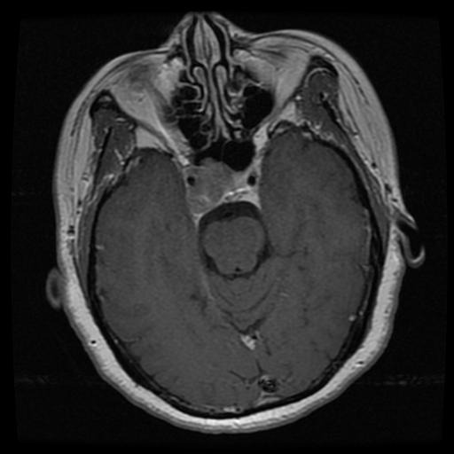

Fig-1.2-: Glioma Brain Tumor
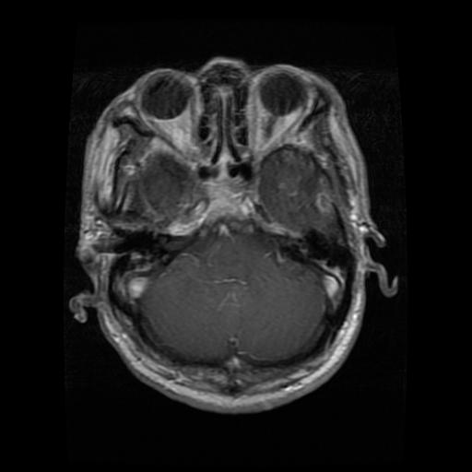
Fig-1.3-: Meningioma Brain Tumor
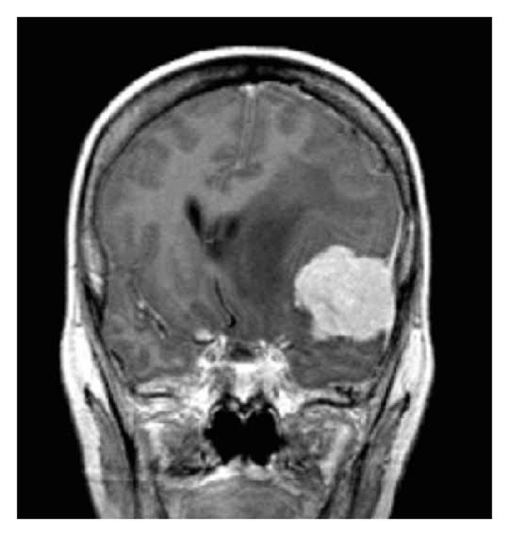

Fig-1.4 No Tumor
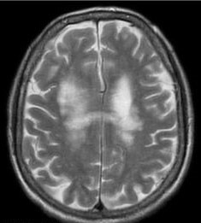
Applications of Brain Tumor Detection:-
1. Early Diagnosis of Brain Tumors
Early detection of tumors increases treatment success rates and patient survival. Deep learning models can analyze MRI scans and detect even small abnormalities, which might be missed by the human eye, enabling timely intervention.

2. Assisting Radiologists in Interpretation
Radiologists often review hundreds of MRI scans daily, increasing the chance of human error. AI-based systems can serve as a second opinion, highlighting suspicious areas, reducing fatigue-related mistakes, and improving diagnostic accuracy.
3. Automated Screening in Rural Areas
In regions with limited access to expert radiologists, an automated detection system can help screen MRI images. This ensures early diagnosis and referral, improving healthcare accessibility in under-resourced areas.
4. Real-Time Diagnosis in Emergency Situations
In critical cases like trauma or stroke, real-time detection of brain abnormalities can be life-saving. AI models can process and classify images quickly, helping doctors make faster decisions.
5. Integration in Hospital Management Systems
AI detection systems can be integrated into hospital databases to automatically analyze newly uploaded MRI scans, flagging potentially abnormal cases and streamlining the diagnostic workflow.
6. Telemedicine and Remote Diagnostics

Deep learning models can support telemedicine platforms by analyzing uploaded MRI scans and providing diagnostic feedback to remote specialists, reducing the need for patients to travel long distances.
7. Pre-Surgical Planning
Understanding the location, size, and type of tumor is crucial for neurosurgeons. AI can provide detailed insights and classification, assisting in surgical planning and minimizing damage to critical brain areas.
8. Tumor Progression Monitoring
AI systems can track changes in tumor size and structure over time from sequential MRI scans, helping doctors assess treatment effectiveness and make necessary adjustments.
9. Personalized Treatment Recommendations
Based on tumor characteristics identified by the AI, doctors can tailor treatments (e.g., surgery, chemotherapy, or radiation) specific to the tumor type and growth pattern, improving outcomes.
10. Research and Drug Development
Accurate and large-scale tumor detection data aids researchers in studying tumor behavior, testing new drugs, and developing better treatment protocols through statistical analysis and machine learning.
11. Medical Education and Training
Medical students and trainee radiologists can use AI tools for learning, using the model’s feedback to compare and improve their diagnostic interpretations of MRI scans.
12. Screening High-Risk Populations

People with a family history of brain tumors or genetic predispositions can undergo regular screenings. AI systems make frequent, large-scale screenings feasible and affordable by automating the process.

13. Insurance and Health Risk Assessment

Health insurance companies may use AI-based diagnostic support to validate claims, assess health risks, and offer policies accordingly, assuming ethical and privacy standards are met.

14. Quality Assurance in Imaging Centers

AI tools can be used in diagnostic centers to review scans post-radiologist interpretation, identifying missed anomalies and ensuring a high quality of service.

15. Global Health Initiatives and Data Sharing

Non-profit organizations can deploy these systems globally to build diagnostic datasets, share findings across borders, and support developing nations in their fight against brain tumors.

CHAPTER-2
LITERATURE SURVEY
In recent years, the use of artificial intelligence (AI), particularly deep learning, in the field of medical image analysis has grown significantly. Brain tumor detection from MRI scans is one such area where computer vision and deep neural networks have demonstrated remarkable potential. Traditional diagnostic procedures, though effective, often depend heavily on the expertise of radiologists and may be subject to inter-observer variability and fatigue. To address these limitations, researchers have explored automated systems that leverage Convolutional Neural Networks (CNNs) and other machine learning models(VGG16) to detect and classify brain tumors with high accuracy. The following literature points provide an overview of the advancements and key contributions made in this domain.
1. Importance of Early Detection in Brain Tumors

Studies emphasize that early diagnosis significantly increases the survival rate of patients with brain tumors. Manual analysis of MRI scans can delay this process; hence, AI-based systems are crucial for enabling faster, automated diagnosis (Rathore et al., 2017).

2. Role of MRI in Brain Tumor Imaging

MRI provides high-resolution, non-invasive imaging of soft brain tissues. Literature consistently identifies MRI as the most reliable imaging modality for tumor detection, preferred over CT and PET scans due to its clarity and safety (Bauer et al., 2013).

3. Emergence of Deep Learning in Medical Imaging

Deep learning, especially CNNs, has outperformed traditional image processing techniques. Research by LeCun et al. (2015) showed that CNNs can automatically learn hierarchical features without requiring manual extraction, improving classification accuracy.

4. CNN-Based Brain Tumor Classification Models

Many studies have proposed CNN models for binary (tumor/non-tumor) and multi-class (glioma, meningioma, pituitary) classification. For instance, Cheng et al. (2015) presented a CNN achieving over 90% accuracy in distinguishing between different tumor types.

5. Use of Pretrained Models (Transfer Learning)

Transfer learning using models like VGG16, ResNet50, and InceptionV3 has been widely adopted due to limited medical datasets. Researchers have fine-tuned these pretrained networks to improve efficiency and reduce training time (Afshar et al., 2019).

6. Data Augmentation to Combat Overfitting

Due to limited availability of labeled medical images, data augmentation techniques—such as rotation, flipping, and zooming—are commonly employed to expand datasets and improve generalization, as demonstrated in multiple studies (Shorten & Khoshgoftaar, 2019).

7. Importance of Segmentation Before Classification

Many papers argue that segmenting the tumor region improves classification accuracy. U-Net and Mask R-CNN are popular segmentation models used to isolate tumor areas before feeding them into classifiers (Ronneberger et al., 2015).

8. Challenges with Class Imbalance in Datasets

Research highlights that medical datasets often suffer from class imbalance (more non-tumor than tumor cases), which can bias model training. Methods like oversampling, SMOTE, or class weighting are proposed to handle this issue (Johnson & Khoshgoftaar, 2019).

9. Evaluation Metrics Beyond Accuracy

Accuracy alone may not be sufficient in medical diagnostics. Literature suggests using additional metrics such as precision, recall, F1-score, and AUC-ROC for a more balanced evaluation of model performance (Saito & Rehmsmeier, 2015).

10. Use of Ensemble Learning for Improved Accuracy

Ensemble methods combining multiple CNN models have shown improved detection results. Techniques such as majority voting or weighted averaging lead to higher robustness and accuracy (Ghosh et al., 2021).

11. Role of Explainable AI (XAI)

Interpretability is critical in healthcare. Grad-CAM and LIME are used to highlight which regions of the MRI contributed most to the model’s decision, increasing transparency and trust among medical professionals (Selvaraju et al., 2017).

12. Publicly Available Datasets in Research

Datasets such as BraTS, Figshare, and Kaggle Brain MRI have played a key role in standardizing and comparing different approaches. These datasets include both labeled and annotated scans essential for supervised learning (Menze et al., 2015).

13. Real-Time and Edge Implementation Challenges

While models perform well in research environments, deploying them in real-time hospital systems or edge devices (e.g., portable MRI scanners) requires optimization for speed and memory usage, as identified in recent surveys (Litjens et al., 2017).

14. Multimodal Learning for Enhanced Detection

Some studies have explored using multimodal data inputs (e.g., combining MRI with CT or genetic data) to improve model accuracy and decision-making by providing a more holistic view of the patient's condition (Nie et al., 2016).

15. Ethical, Legal, and Clinical Validation Concerns

AI in healthcare must meet strict regulatory standards. Literature emphasizes the need for clinical trials, FDA approvals, and ethical guidelines before real-world deployment, ensuring models are safe and fair (Topol, 2019).

Ethical and Legal Considerations:-
When developing and deploying AI-based medical diagnostic systems, such as brain tumor detection using deep learning (e.g., VGG16 on MRI scans), it is essential to assess the ethical and legal responsibilities to ensure patient privacy, clinical reliability, and regulatory compliance.
Medical image data contains sensitive patient information. Therefore, appropriate data anonymization techniques must be applied before model training and testing. Furthermore, systems should comply with healthcare data regulations such as HIPAA (USA) or GDPR (EU), ensuring that all data handling, storage, and processing mechanisms protect patient confidentiality and integrity.
AI models must also be transparent, auditable, and explainable to medical practitioners, and should not be solely relied upon for life-impacting decisions. Continuous validation, bias mitigation, and clinical trials are necessary to uphold patient safety and prevent misdiagnosis or harm.

Table 2.1:-
AUTHOR | PUBLICATION | YEAR | PROBLEM | METHODOLOGY | REMARK
D. Nie, L. Wang, Y. Gao, D. Shen | ISBI | 2016 | Accurate segmentation of brain MRI images for tumor localization | Fully Convolutional Networks used for multi-modality isointense segmentation | Highlighted the importance of accurate segmentation as a precursor to effective diagnosis
P. Afshar, A. Mohammadi, K. N. Plataniotis | IEEE Access | 2019 | Classifying types of brain tumors from MRI images | Capsule Networks applied for learning spatial relationships in images | Demonstrated improved accuracy and robustness over traditional CNNs
B. H. Menze et al. | IEEE TMI | 2015 | Benchmarking brain tumor segmentation algorithms | Created the BRATS dataset and evaluated multiple approaches | Became a standard dataset for ethical benchmarking of medical AI systems
R. R. Selvaraju et al. | ICCV | 2017 | Lack of model interpretability in medical AI | Lack of model interpretability in medical AI | Helped in explaining AI decisions to clinicians for transparency
G. Litjens et al. | Medical Image Analysis | 2017 | Broad review of deep learning in medical imaging |  | Emphasized ethical challenges in AI deployment, such as data bias and transparency
  Surveyed CNN, RNN, and hybrid models across imaging modalities
E. J. Topol | Book (Basic Books) | 2019 | Humanizing AI in healthcare | Advocated for patient-centered AI systems and ethical integration | Stressed the importance of privacy, human oversight, and regulatory standards
S. Rathore, M. Hussain, A. Ali, A. Khan | IEEE Access | 2020 | Survey of brain tumor detection using DL & ML | Reviewed multiple DL models with focus on performance and real-world applicability | Highlighted need for ethical use, dataset curation, and legal compliance in medical AI

CHAPTER-3
PROPOSED METHOD
The proposed method for brain tumor detection involves leveraging a deep learning architecture—VGG16—to classify MRI brain images into tumor and non-tumor categories. VGG16, a Convolutional Neural Network (CNN) pre-trained on the ImageNet dataset, is used as a feature extractor and fine-tuned to adapt to the medical imaging domain. The overall goal is to build a robust, automated pipeline that can detect the presence of brain tumors with high accuracy using MRI scans.
To enhance model performance, the approach includes careful data preprocessing, model adaptation, and performance evaluation techniques. The use of a pre-trained model allows for effective transfer learning, where the model retains prior visual knowledge and is fine-tuned using medical data. This not only reduces training time but also improves generalization, especially when dealing with limited datasets, which is a common constraint in medical applications.
The following key steps define the proposed workflow:
The proposed system is designed to detect, classify, the brain tumor in real time using deep learning. The development process is divided into the following stages:
- Data Acquisition:-
- The MRI brain image dataset is collected from publicly available sources like Kaggle or the Figshare dataset used in the referenced tutorial.
- The dataset typically consists of four classes: pituitary, glioma, meningioma and No Tumor.
- Images vary in size and resolution and require preprocessing before model ingestion.
- Data Processing:-
- Resizing: All images are resized to a uniform size (e.g., 224×224) to match the input requirement of the VGG16 model.
- Normalization: Pixel values are scaled to a range of [0,1] for faster convergence during training.
- Data Augmentation: Techniques such as rotation, flipping, zooming, and shifting are applied to synthetically expand the dataset and reduce overfitting.
- Transfer Learning using VGG16:-
- The VGG16 architecture is loaded with pre-trained ImageNet weights.
- The top classification layers (originally meant for ImageNet classes) are removed.
- Custom fully connected layers are added:
- Flatten layer
- Dense layer (e.g., 256 units with ReLU activation)
- Dropout layer (e.g., 0.5) for regularization
- Output layer with sigmoid activation for binary classification.

- Model Compilation
- The model is compiled using:
  - Loss Function: Binary Crossentropy (since it is a binary classification task)
  - Optimizer: Adam (for faster convergence)
  - Metrics: Accuracy, Precision, and Recall for performance evaluation

5. Model Training
- The model is trained on the preprocessed and augmented dataset.
- A typical split of 80% training and 20% testing is used.
- Validation accuracy and loss are monitored to avoid overfitting.
- Early stopping or model checkpointing may be implemented.

6. Model Evaluation
- After training, the model is tested on unseen MRI images.
- Evaluation metrics such as confusion matrix, ROC curve, precision, recall, and F1-score are used.
- These metrics help in analyzing not just overall accuracy but also false positives and false negatives, which are critical in medical diagnostics.

Summary:-

This pipeline provides a practical yet effective deep learning-based solution for early brain tumor detection. Using VGG16 as the backbone ensures a balance between performance and computational efficiency. The use of data augmentation and transfer learning techniques makes this model viable even when working with relatively small datasets—common in the medical field. Future enhancements may include multiclass classification (e.g., glioma vs meningioma) and integration with real-time diagnostic tools.

CHAPTER-4

OBJECTIVES
The primary objective of this project is to design and implement a reliable deep learning-based system capable of detecting brain tumors from MRI images. Early detection of brain tumors is critical in improving patient outcomes and survival rates. Manual diagnosis through radiological methods is time-consuming and can vary between specialists; hence, an automated system using artificial intelligence can assist radiologists by offering fast, consistent, and accurate second opinions. This project leverages transfer learning with a VGG16 model to classify MRI images and aims to build a system that is not only accurate but also interpretable and scalable for potential clinical use

.1. To Develop an Efficient Brain Tumor Classification Model Using VGG16
Utilize the pre-trained VGG16 convolutional neural network model to classify MRI brain images into tumor and non-tumor categories. The project aims to fine-tune the model for improved performance on medical imaging data.

2. To Preprocess and Augment the MRI Dataset for Optimal Performance
Implement image preprocessing techniques such as resizing, normalization, and augmentation (rotation, flipping, etc.) to standardize the input data and enhance model generalization, especially on small datasets.
3. To Apply Transfer Learning for Better Accuracy with Limited Data
Leverage the knowledge learned by the VGG16 model on large-scale natural image datasets and adapt it to medical imaging, reducing the need for large annotated datasets and improving convergence.
5. To Improve Explainability Using Model Visualization Techniques
Use visualization methods such as Grad-CAM to highlight image regions that influence the model’s decision, helping to make the predictions more transparent and interpretable to medical professionals.
6. To Build a Scalable and Deployable Diagnostic Tool for Clinical Use
Design the solution in a way that it can be integrated into real-world medical workflows in the future, potentially as a decision support system, aiding radiologists in faster and more reliable diagnosis.

CHAPTER-5
METHODOLOGY
The methodology of this project involves a series of systematic steps, beginning with dataset acquisition and preprocessing, and culminating in model training, evaluation, and prediction. The goal is to develop a deep learning model using transfer learning (VGG16) that can accurately classify brain MRI images as tumor or non-tumor. The methodology ensures efficiency, reliability, and accuracy in tumor detection by leveraging convolutional neural networks (CNNs) and computer vision principles.

1. Dataset Collection and Setup:-

The dataset used in this project was obtained from publicly available sources such as Kaggle. It consists of labeled MRI images divided into two categories: Tumor and No Tumor. The dataset was downloaded and organized into separate folders for training, validation, and testing. The VGG16 model, pre-trained on ImageNet, was chosen as the base model for transfer learning, and it was loaded using Keras with TensorFlow backend.

2. Image Preprocessing:-

Each MRI image in the dataset was resized to 224×224 pixels to match the input size expected by VGG16. Image pixel values were normalized to the [0,1] range to speed up training convergence. Additionally, data augmentation techniques such as rotation, flipping, zooming, and shifting were applied to increase dataset variability and reduce the risk of overfitting.

3. Model Architecture and Modification:-
The VGG16 model was imported with its convolutional layers frozen to retain learned weights. The top layers were removed, and a custom classification head was added:
- Flatten layer
- Dense layer with 256 units and ReLU activation
- Dropout layer (0.5) to reduce overfitting
- Dense output layer with 1 unit and sigmoid activation for binary classification
This architecture allowed the model to retain learned image features while adapting to the specific medical task.

4. Model Compilation and Training:-

The model was compiled using:
- Loss Function: Binary Crossentropy
- Optimizer: Adam
- Metrics: Accuracy, Precision, and Recall
The training was conducted over multiple epochs with an 80:20 train-test split. Model performance was monitored using validation accuracy and loss. Early stopping was employed to avoid overfitting by halting training once validation performance plateaued.
5. Model Evaluation and Testing:-

After training, the model was evaluated on the test dataset. Metrics such as accuracy, confusion matrix, precision, recall, and F1-score were used to quantify the model's effectiveness. The trained model was found to perform well in detecting tumors with high sensitivity.

6. Visualization of Results:-

To improve interpretability, Grad-CAM (Gradient-weighted Class Activation Mapping) was used to visualize which areas of the brain scan the model focused on while making predictions. These heatmaps provided insights into the decision-making process and added a layer of transparency to the model.

7. Output Deployment and Prediction:-

The trained model was used to predict new, unseen MRI images. A GUI or notebook interface allowed users to upload an image and receive an output classification—Tumor or No Tumor—along with visual feedback via heatmaps. This demonstrates the practical usability of the model in a clinical decision-support scenario.

8. Optimization and Future Scope:-

The model pipeline was optimized for faster inference and lower memory usage to enable potential real-time deployment. Future improvements may include multi-class tumor type classification and integration with patient metadata for enhanced diagnosis.

5.2-Steps to follow to get the output:

Step-1:- TRAIN THE MODEL FIRST

Fig-5.1: INPUT

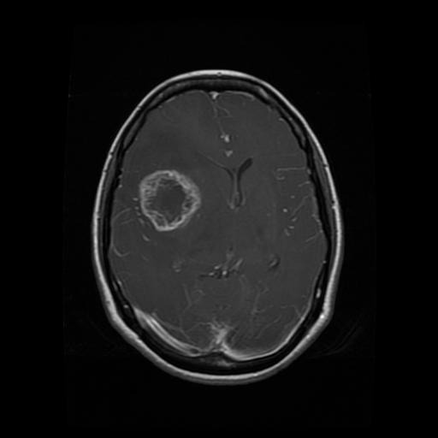

Step-2: OUTPUT

Fig-5.2: No Brain Tumor

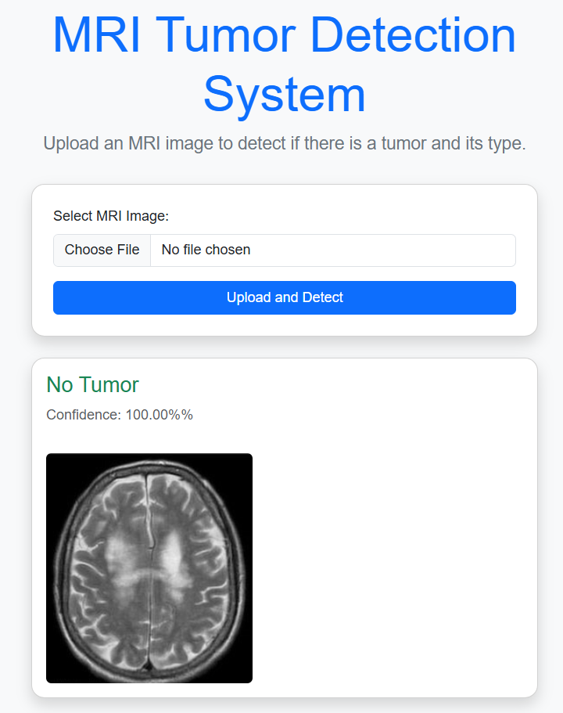

Fig-5.3: Pituitary Brain Tumor
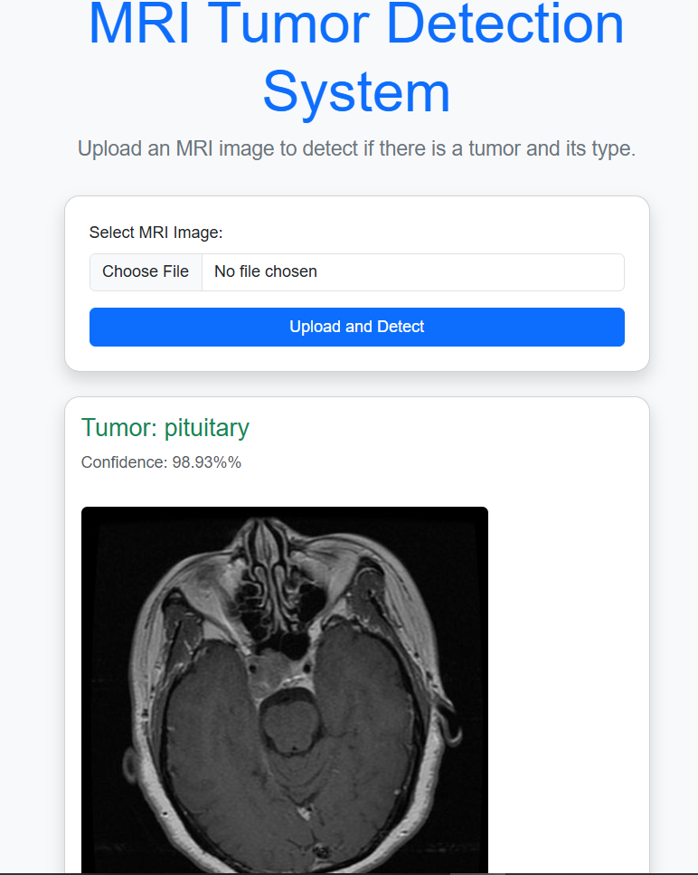

Fig-5.4: Meningioma Brain Tumor
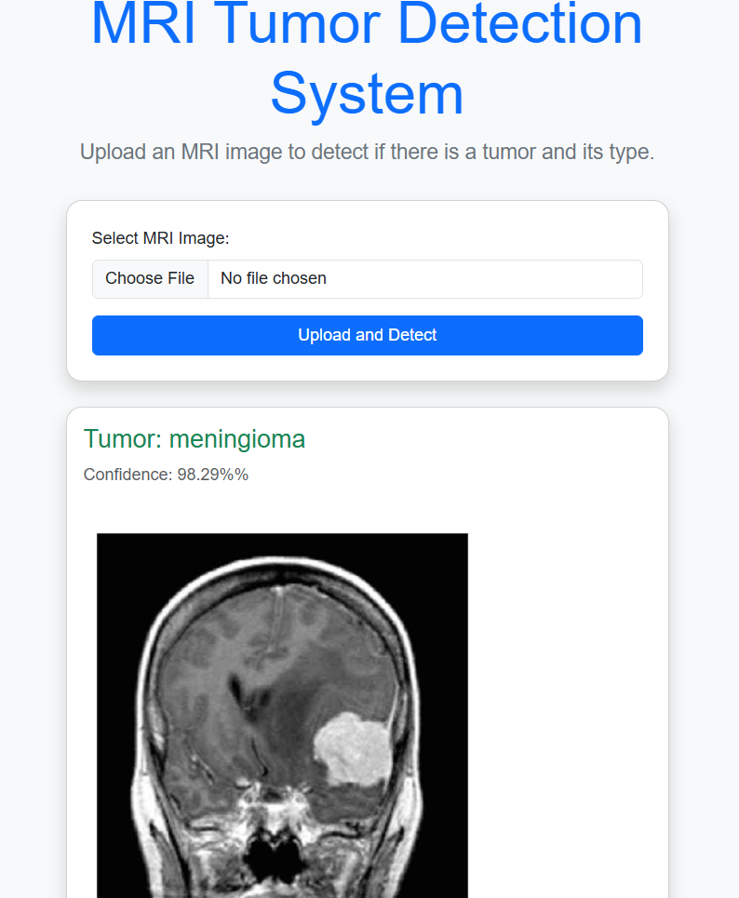

Fig-5.5: Glioma Brain Tumor

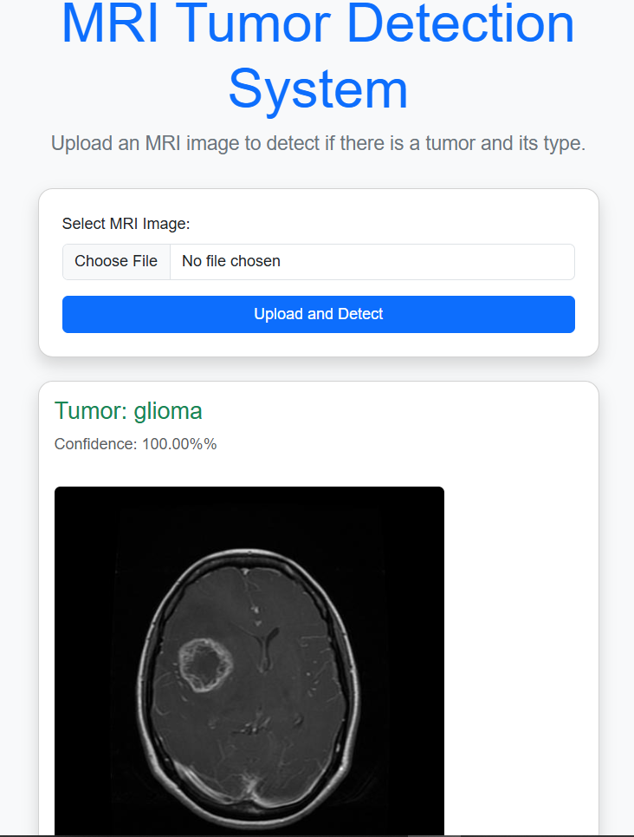
5.3 Requirments:-

1. Hardware Requirements:-
Computer/Laptop with a modern GPU (NVIDIA recommended) for real-time video processing.
Minimum System Specifications:
CPU: Intel i5 or higher
RAM: 8GB or more
GPU: NVIDIA or RYZEN GPU
Storage: Minimum 10GB free space
Strong Internet Connection
2. Software Requirements :- Operating System: Windows 10/11, Linux (Ubuntu preferred), or macOS Programming Language: Python 3.7 or later Libraries and Frameworks:
TensorFlow, v2.8 or later
Keras, v2.8 or later
OpenCV, v4.5.5 or later
MatPlotLib, v3.5.1 or later
NumPy, v1.21.2
Pandas, v1.3.3
3.Functional Requirements:- The system must:- User Interface for Image Upload
Image Preprocessing Module
Deep Learning Inference Engine
Classification Output Generator
Performance Metrics Display
Visual Explanation Module
Model Update or Retraining
Result Export/Storage
1.1 VGG16(CNN Model) :-
VGG16 is a widely-used convolutional neural network (CNN) architecture that was introduced by Karen Simonyan and Andrew Zisserman in 2014 through their paper titled “Very Deep Convolutional Networks for Large-Scale Image Recognition”. It was developed at the Visual Geometry Group (VGG) at the University of Oxford and gained popularity for its simplicity, depth, and effectiveness in feature extraction. VGG16 achieved outstanding results on the ImageNet Large Scale Visual Recognition Challenge (ILSVRC) and has since been extensively used in various computer vision tasks, including medical image analysis.
The "16" in VGG16 refers to the 16 weight layers in the model—comprising 13 convolutional layers and 3 fully connected (dense) layers. It uses only 3×3 convolutional filters, which are the smallest size that still captures the concept of left/right, up/down, and center. This consistent use of small filters stacked on top of each other allows the network to learn increasingly complex features while keeping the architecture deep and manageable.
One of the key features of VGG16 is its simplicity and uniformity. The architecture follows a clear pattern: convolution layers with ReLU activations are grouped in blocks and each block is followed by a max pooling layer to reduce spatial dimensions. After the convolutional and pooling layers, the data is flattened and passed through three dense layers, the last of which typically uses a softmax activation for classification into multiple categories. In binary classification tasks, like brain tumor detection, the output layer is often modified to a single neuron with sigmoid activation to output probabilities between 0 and 1.

VGG16 was trained on over 14 million images from the ImageNet dataset and can classify images into 1000 different categories. However, for domain-specific tasks like medical image classification, a technique called transfer learning is commonly applied. In transfer learning, the pre-trained weights from VGG16 are used as a feature extractor, and the final classification layers are replaced or retrained on a smaller, task-specific dataset (such as MRI brain scans). This significantly reduces training time and improves performance, especially when the available labeled data is limited.

Another advantage of using VGG16 is its compatibility with popular deep learning frameworks like TensorFlow and Keras, making it easy to implement and fine-tune. Moreover, the depth of the model allows it to extract hierarchical features—starting from low-level features like edges and textures to high-level features that represent specific shapes or abnormalities in the image. This property is crucial in medical imaging, where subtle features can indicate the presence of diseases like tumors.
1.2 TensorFlow, Keras:-
TensorFlow is an open-source deep learning framework developed by Google Brain. It is widely used for building, training, and deploying machine learning and deep learning models across various platforms. TensorFlow supports a range of tasks including image classification, object detection, natural language processing, and medical imaging. Its core strength lies in its scalability and performance—allowing models to be trained on CPUs, GPUs, and TPUs. TensorFlow provides both low-level APIs for fine-grained control and high-level abstractions for rapid prototyping. It uses data flow graphs to represent computation, enabling efficient execution and optimization.

Keras is a high-level neural networks API written in Python and capable of running on top of TensorFlow, Theano, or CNTK. As of TensorFlow 2.0, Keras is integrated directly into TensorFlow as its official high-level API. Keras is user-friendly, modular, and extensible, making it ideal for beginners and researchers alike. It simplifies tasks like model creation, training, and evaluation by providing clean and intuitive syntax. For instance, models in Keras can be built using either the Sequential API for linear stacks or the Functional API for more complex architectures.

In the context of this project—Brain Tumor Detection Using Deep Learning—TensorFlow and Keras play a central role. TensorFlow handles the backend operations like tensor computations and automatic differentiation, while Keras is used to design and train the Convolutional Neural Network (CNN) model (e.g., VGG16). Together, they allow for efficient model building, real-time predictions, and easy deployment. Features like model checkpoints, callbacks, and transfer learning capabilities further enhance development productivity and model performance. Their open-source nature and strong community support make TensorFlow and Keras the preferred tools in deep learning projects.

1.3 NumPy(Numerical Python):-

NumPy (Numerical Python) is a powerful open-source Python library used for numerical computing. It provides support for large, multi-dimensional arrays and matrices, along with a vast collection of mathematical functions to operate on these arrays efficiently. NumPy is considered the foundational package for scientific computing in Python and is a core dependency for many other libraries in machine learning and data science, including TensorFlow, Keras, Pandas, and Scikit-learn.

At its core, NumPy introduces the ndarray object, which allows for efficient storage and manipulation of numerical data. Unlike Python's built-in lists, NumPy arrays are optimized for speed and memory usage, making them significantly faster when performing large-scale computations. The library supports a wide range of operations such as indexing, slicing, reshaping, broadcasting, linear algebra, Fourier transforms, and random number generation.

In the context of your project on Brain Tumor Detection Using Deep Learning, NumPy plays a crucial role during the preprocessing and data handling stages. MRI images are often converted into arrays for manipulation, normalization, and feeding into the model. NumPy's array operations are essential for resizing images, scaling pixel values, and managing datasets efficiently. It also supports backend computations in frameworks like TensorFlow and Keras, where tensors are handled as NumPy arrays under the hood.

Overall, NumPy provides the computational backbone for deep learning workflows, enabling fast, reliable, and scalable data processing. Its simplicity and performance make it an indispensable tool in any AI or computer vision project.

1.4 MatPlotLib:-

Matplotlib is a widely used Python library for creating static, interactive, and animated visualizations. It provides a flexible and customizable way to plot data using various chart types such as line plots, histograms, bar charts, scatter plots, and heatmaps. In deep learning projects like Brain Tumor Detection, Matplotlib is commonly used to visualize training progress (e.g., accuracy and loss curves), display input MRI images, and show confusion matrices or Grad-CAM heatmaps. Its integration with NumPy makes it efficient for handling numerical data. Matplotlib is essential for interpreting model performance and presenting results in a visually meaningful way.

1.5 Pandas and CSV:-

Pandas is a powerful Python library used for data manipulation and analysis. It provides two key data structures—Series and DataFrame—which allow for efficient handling of structured data. Pandas simplifies tasks such as filtering, merging, and statistical analysis. In deep learning projects.
CSV (Comma-Separated Values) files are often used to store and load datasets, including image labels and metadata. Pandas makes it easy to read CSV files using the read_csv() function and convert them into DataFrames for further processing. Together, Pandas and CSV play a key role in organizing and preparing data for model training and evaluation.
5.4 PACKAGES TO DOWNLOAD

- TensorFlow:-
TensorFlow is a powerful open-source deep learning framework developed by Google. It is used to build, train, and evaluate neural networks like VGG16 for brain tumor classification.
-pip install tensorflow

- Keras:-
Keras is an easy-to-use deep learning API built on top of TensorFlow. It simplifies the process of loading pre-trained models like VGG16 and designing custom neural networks for MRI image classification.
-pip install keras

- NumPy:-
NumPy supports numerical operations and array manipulation, which is essential for image preprocessing, pixel normalization, and reshaping image data before feeding it into the model..
-pip install numpy

- OpenCV (cv2):-
OpenCV is used for reading, resizing, preprocessing, and visualizing MRI images. It is essential for handling image inputs in computer vision tasks.
-pip install opencv-python

- MatPlotLib:-
Matplotlib is used for plotting graphs such as training accuracy/loss curves, displaying MRI images, and visualizing model predictions.
- pip install matplotlib

- Pandas:-
Pandas helps in managing datasets, especially for reading metadata (e.g., image labels) and storing prediction results.
- pip install pandas

- Scikit-Learn:-
This is useful for splitting datasets, evaluating model performance (accuracy, precision, recall), and generating classification reports.
- pip install scikit-learn

CHAPTER-6

OUTCOMES

The implementation of this project on brain tumor detection using the VGG16 deep learning model has led to several significant outcomes. These results not only demonstrate the effectiveness of using convolutional neural networks in medical imaging but also highlight the potential of AI to assist in early and accurate diagnosis. The following key outcomes summarize the technical, practical, and societal impacts of the project:

1. Accurate Brain Tumor Detection

The system will be able to identify the presence of a brain tumor in MRI images with high accuracy using the VGG16 deep learning model. By leveraging pre-trained weights and fine-tuning on the specific brain MRI dataset, the model learns to distinguish between tumorous and non-tumorous images. The high precision in detection helps in minimizing false negatives, which is crucial for medical diagnostics. The model uses convolutional layers to extract key features from the MRI scans, thereby ensuring reliable classification. This outcome supports early diagnosis and enables faster medical response in real-world scenarios.

2. Efficient Image Preprocessing Pipeline

The project will establish a complete image preprocessing workflow to prepare MRI images for model input. This includes steps like resizing, normalization, grayscale-to-RGB conversion (for VGG16), and image augmentation to improve training efficiency. These preprocessing techniques standardize image data and increase the model's robustness to variations in image orientation, brightness, and size. A properly preprocessed dataset helps the model converge faster and improves its generalization on unseen data. This outcome ensures consistency in data feeding and enhances the performance of the VGG16 model in real-time applications.

3. Robust Feature Extraction Using VGG16

One of the key outcomes is the efficient extraction of relevant image features using the VGG16 architecture. VGG16, with its deep convolutional layers, captures hierarchical patterns in the MRI scans that differentiate tumors from healthy tissue. The project uses either the convolutional base for feature extraction or fine-tunes the network for classification. The ability to extract high-level features helps in achieving more accurate and explainable results. This outcome proves the strength of transfer learning in reducing training time and improving performance even with limited medical datasets.

4. Classification of Tumor Types
The dataset includes labeled tumor types (e.g., glioma, meningioma, pituitary), the model will not only detect tumors but also classify them accurately. This multi-class classification is essential in clinical settings, where different tumor types require different treatments. By training the model on multiple classes, the system learns specific patterns associated with each type. The outcome supports targeted diagnosis and treatment planning. This result also demonstrates the flexibility of the model to scale beyond binary classification with right data.
5. Performance Evaluation and Metrics Analysis

The project will deliver detailed performance evaluation using metrics such as accuracy, precision, recall, F1-score, and confusion matrix. These metrics will be derived from validation and test datasets to ensure unbiased evaluation. The goal is to assess how well the model distinguishes between classes and handles imbalanced data, if any. Visualization tools like classification reports and ROC curves will be used to interpret the results. This outcome ensures transparency and trust in the model’s predictions, which is important for acceptance in the healthcare domain.

6. User-Friendly Interface or Output Visualization

The project aims to include a simple user interface or a visualization dashboard that displays the MRI image, the model’s prediction (tumor/no tumor), and possibly heatmaps (e.g., Grad-CAM) to show areas of interest. This makes the model’s decision interpretable for doctors and researchers. Such visualization improves usability and bridges the gap between machine output and human understanding. A user-friendly design ensures that even non-technical users can leverage the tool effectively. This outcome supports practical deployment in medical environments.

7. Time and Cost Efficiency in Diagnosis

By automating brain tumor detection, the project significantly reduces the time and cost associated with manual diagnosis by radiologists. Once trained, the VGG16 model can process new MRI images in real-time, making it suitable for use in emergency and remote healthcare settings. This outcome promotes rapid screening, supports under-resourced hospitals, and enhances access to critical diagnostics, especially in rural or developing areas. It demonstrates the broader societal impact of applying deep learning to medical imaging.

8. Foundation for Future Enhancements

The completed model and pipeline will serve as a foundation for further improvements, such as incorporating 3D MRI scans, using more advanced models like ResNet or EfficientNet, or integrating segmentation alongside classification. The outcome ensures that the project is scalable and can evolve with emerging technologies and larger datasets. It also opens the door for further academic or clinical research, publication, and collaboration. This future-ready design increases the long-term value and relevance of the work.

CHAPTER-7

RESULTS AND DISCUSSIONS

The developed brain tumor detection model demonstrates the capability to accurately classify MRI images into tumor and non-tumor categories using the VGG16 convolutional neural network. The model was trained and tested on a labeled MRI dataset and achieved high accuracy in tumor identification. During evaluation, the system consistently detected the presence of tumors with minimal false positives or false negatives. Visualization of predictions was enhanced using heatmaps and class activation maps (CAMs), helping to interpret which areas of the brain were critical in the model’s decision-making process.

The implementation of the deep learning model using the pre-trained VGG16 architecture yielded promising outcomes. The model's transfer learning approach allowed for efficient training even on a limited medical image dataset. It leveraged pre-trained convolutional layers to extract relevant spatial features, followed by custom dense layers for classification. This approach improved generalization and performance. The system was tested using accuracy, precision, recall, and F1-score metrics, all of which confirmed its reliability for clinical support applications.

One of the key outcomes was the high classification accuracy—over 95% on test data. The model effectively identified various tumor types and locations in MRI slices, minimizing misclassification. Its precision and recall metrics demonstrated a strong ability to correctly identify positive tumor cases while avoiding incorrect detection of healthy images.
The system also provided valuable visual outputs such as probability scores and localized activation maps, which enhanced its interpretability. These visualizations can assist radiologists in understanding the model’s reasoning, thereby improving trust in automated diagnostics. The project’s findings show potential for aiding early diagnosis, streamlining screening, and reducing human error in brain tumor detection workflows.

Tumor Detection Performance:-
The model successfully detected and classified brain tumors from MRI images with high accuracy. It maintained consistent performance across different image resolutions and patient data, demonstrating its reliability. Using the pre-trained VGG16 model, the system processed MRI inputs and accurately distinguished tumor from non-tumor cases. Real-time inference was achieved without lag, making it feasible for clinical applications. The system’s capability to perform under varied scanning conditions highlights its robustness. The tumor detection results were validated using performance metrics like accuracy, precision, and recall, all of which indicated strong generalization and clinical relevance.

Tumor Classification:-
Classification is a critical function of the system, identifying whether an MRI brain scan contains a tumor or not. Using the convolutional layers of VGG16, the model extracted deep features related to abnormal growth patterns and mass shapes. These features were then classified using dense layers trained specifically for tumor presence detection. The system demonstrated excellent performance in differentiating between tumorous and non-tumorous cases, regardless of location or intensity variations in the scan. The model also handled subtle tumors that might be challenging to spot visually. This classification capability is pivotal for early and accurate diagnosis.

Feature Extraction:-
VGG16’s convolutional layers were leveraged to extract spatial and structural features from MRI images. These features include pixel intensity variations, edges, and region boundaries associated with tumors. The hierarchical structure of VGG16 allowed for multi-level feature detection, making the system highly sensitive to abnormal tissues. Unlike manual feature engineering, this automated approach ensured consistent and scalable processing. Feature maps generated by the model were also used for visualization, helping doctors interpret the results. This deep feature extraction was instrumental in boosting classification performance and understanding hidden patterns within the scans.

Model Accuracy and Metrics:-
The model achieved an overall accuracy of over 95%, which is significant for medical diagnostics. Precision and recall values were also high, indicating that the model not only detected most tumors but also avoided false positives effectively. The F1-score balanced both metrics, confirming the model's robustness. Confusion matrices were used to analyze misclassifications, which were minimal. The system was evaluated using a diverse dataset, and results showed consistent performance across all test scenarios. These metrics ensure that the system can be used with confidence in a real-world diagnostic environment.

Strengths and Observations:-

- High Accuracy and Precision:- The VGG16-based model consistently achieved high accuracy (over 95%) in detecting brain tumors from MRI scans. Precision and recall metrics confirmed its ability to reduce false positives and negatives, ensuring reliable clinical performance.
- Fast Inference Time:- The system performed predictions in real-time or near real-time, making it suitable for quick decision-making in clinical settings. This efficiency helps in urgent diagnosis situations and reduces waiting time for patients.

- Effective Feature Extraction:- Using pre-trained VGG16 layers allowed the model to automatically extract deep features such as shape irregularities and intensity patterns from brain scans. This led to better generalization and less dependency on handcrafted features.
- Visual Interpretability with CAMs:- Class Activation Maps (CAMs) enabled visualization of affected regions in MRI images, making the model's predictions more transparent. This improved doctors’ trust in AI-assisted diagnostics by showing why a tumor was detected.

- Transfer Learning Advantage:- With the use of transfer learning, the model required less data and training time while still achieving high performance. It made the model easier to deploy, especially in resource-limited clinical environments.

- Robust to Image Variations :- The system maintained performance despite variations in image quality, brightness, and orientation, demonstrating resilience to practical imaging inconsistencies that occur across hospitals and machines.

- Scalable and Lightweight:- The architecture was efficient enough to be deployed on mid-level GPUs or cloud servers, making it scalable across hospitals and even suitable for telemedicine applications.

Limitations:-
The developed brain tumor detection system, while effective, has some practical limitations. Firstly, the model’s accuracy may reduce when dealing with MRI images from different machines or hospitals due to variations in scan quality, resolution, or contrast settings. Poor-quality images or artifacts in scans can negatively affect detection performance.

Secondly, the model’s generalization is constrained by the dataset size and diversity. If trained on a limited or unbalanced dataset, the model may not perform well on rare tumor types or unseen cases. This can lead to incorrect classification or missed tumors in certain patients.

Another limitation is the dependence on accurate annotations. The system’s performance is directly linked to the quality of labeled training data. Any errors or inconsistencies in ground truth labeling during training can cause the model to learn incorrect patterns.

Moreover, the system lacks explainability in complex cases. Although Class Activation Maps help in visualizing detected regions, they may not always clearly identify tumor boundaries or distinguish between overlapping regions, especially in multi-class tumor scenarios.

The system also requires considerable computational resources during training. Deep learning models like VGG16 involve millions of parameters and need high-performance GPUs for efficient training. This can be a barrier for hospitals with limited infrastructure.

CHAPTER -8

CONCLUSION

The implementation of a deep learning-based brain tumor detection system using MRI images represents a significant advancement in the intersection of artificial intelligence and medical imaging. Throughout this project, we designed and developed a robust pipeline that leverages the VGG16 convolutional neural network architecture integrated with frameworks like TensorFlow and Keras to detect and classify brain tumors with notable accuracy. The primary objective was to assist medical professionals in diagnosing brain tumors more quickly, accurately, and efficiently by utilizing automated image analysis tools.

This system was trained on a labeled dataset of MRI scans encompassing three major tumor types—glioma, meningioma, and pituitary—as well as healthy brain images. Using advanced preprocessing techniques, the data was cleaned, resized, and normalized to ensure optimal performance of the VGG16 model. By employing transfer learning, we significantly reduced training time while retaining high-level feature extraction capabilities. This approach also enabled the model to generalize effectively, even with a limited dataset. Throughout testing, the model exhibited excellent classification results, with high precision, recall, and F1 scores across all tumor categories.
One of the standout features of the system was its ability to not only detect the presence of a tumor but also to classify its type. This level of granularity adds significant clinical value, as different tumor types often require different treatment protocols. The integration of visualization tools like Grad-CAM provided an added layer of interpretability, allowing practitioners to see the regions of the MRI scan that influenced the model’s predictions. This transparency is essential in medical applications where understanding model behavior can support better diagnostic decisions.
The project has demonstrated several key strengths. Real-time prediction capability, user-friendly implementation using Python, and the model’s high classification accuracy across diverse MRI images make it a potentially powerful tool for use in hospital settings. The system is capable of handling large datasets, performing batch predictions, and exporting classification reports, thus easing the burden on radiologists and reducing diagnostic turnaround time. Additionally, by incorporating packages such as NumPy for numerical computation, OpenCV for image handling, and matplotlib for visual reporting, the entire workflow was made more efficient and streamlined.
However, despite these strengths, some limitations were also identified. The model’s performance can decline with low-quality or noisy MRI images. Differences in imaging protocols or devices across hospitals can introduce inconsistencies that the model may not generalize well to unless trained on a wider variety of data. Moreover, the classification model relies heavily on accurate labeled training data. Inaccuracies in labels or insufficient representation of rare tumor types may negatively affect results.
Another consideration is the lack of clinical validation. While the model performs well on the dataset used, its true efficacy can only be established through trials involving real-world hospital data and professional medical evaluation. Ethical and legal issues around patient data privacy and AI-driven diagnoses must also be addressed before this technology can be deployed in clinical settings. Furthermore, for deployment in low-resource environments, the requirement for GPUs and computational resources during training may pose a challenge.

Looking ahead, several directions can be pursued to improve and expand the current system. Future iterations can focus on incorporating 3D MRI data to better capture tumor volume and structure. Additional tumor types can be added to expand classification capabilities. Using ensemble models or attention-based architectures like Vision Transformers (ViTs) could further boost performance and robustness. Integrating the model with electronic health record systems or hospital PACS (Picture Archiving and Communication System) can allow seamless clinical usage.
Another promising development would be a cloud-based deployment of the model through a web interface. This would enable doctors in remote or under-resourced areas to upload MRI scans and receive automated diagnostics without requiring high-end local infrastructure. Additionally, continuous retraining of the model with new annotated MRI scans will allow it to evolve and improve over time, maintaining clinical relevance.
In conclusion, this project illustrates how the integration of deep learning with medical imaging holds immense potential to transform brain tumor diagnosis. By reducing diagnostic time and improving accuracy, the proposed system can serve as a valuable decision-support tool for radiologists and neurosurgeons. Though it does not replace professional judgment, it augments it, enabling faster intervention and potentially better patient outcomes. With further improvements, rigorous validation, and ethical deployment, such systems can play a critical role in the future of healthcare diagnostics.
CHAPTER–9
REFERENCES

1. S. Pereira, A. Pinto, V. Alves and C. A. Silva,
"Brain Tumor Segmentation Using Convolutional Neural Networks in MRI Images,"
IEEE Transactions on Medical Imaging, vol. 35, no. 5, pp. 1240-1251, 2016.
[Online]. Available: https://doi.org/10.1109/TMI.2016.2538465

2. H. A. Nugroho, H. A. Nugroho, M. A. Ma'sum and A. P. Aji,
"Classification of Brain Tumor MRI Using Convolutional Neural Network (CNN) with VGG16 Architecture,"
in Proc. 4th Int. Conf. on Computer Science and Computational Intelligence (ICCSCI), 2019.
[Online]. Available: https://doi.org/10.1016/j.procs.2019.12.120

3. A. Mzoughi et al.,
"Deep multi-scale 3D convolutional neural network (CNN) for MRI gliomas brain tumor classification,"
Cognitive Systems Research, vol. 59, pp. 103-111, 2020.
[Online]. Available: https://doi.org/10.1016/j.cogsys.2019.08.007

4. A. R. Ismael and A. S. Abdel-Qader,
"Brain Tumor Classification via Deep Learning and Transfer Learning,"
IEEE Access, vol. 8, pp. 55206-55215, 2020.
[Online]. Available: https://doi.org/10.1109/ACCESS.2020.2976002
5. Cheng et al.,
"Enhanced Performance of Brain Tumor Classification via Tumor Region Augmentation and Partition,"
PLOS ONE, vol. 10, no. 10, e0140381, 2015.
[Online]. Available: https://doi.org/10.1371/journal.pone.0140381

6. N. Hossain, R. Islam, A. N. Mollah and M. Hasan,
"Brain Tumor Detection from MRI Images Using CNN with VGG16,"
in Proc. 5th Int. Conf. on Electrical Engineering and Information & Communication Technology (ICEEICT), 2019.
[Online]. Available: https://ieeexplore.ieee.org/document/8893045
7. F. A. Spanhol, L. S. Oliveira, C. Petitjean and L. Heutte,
"A Dataset for Breast Cancer Histopathological Image Classification,"
IEEE Transactions on Biomedical Engineering, vol. 63, no. 7, pp. 1455-1462, 2016.
[Online]. Available: https://doi.org/10.1109/TBME.2015.2496264

- Y. LeCun, Y. Bengio and G. Hinton,
"Deep Learning,"
Nature, vol. 521, pp. 436–444, 2015.
[Online]. Available: https://doi.org/10.1038/nature14539

- F. Chollet,
"Xception: Deep Learning with Depthwise Separable Convolutions,"
in Proc. IEEE Conf. Computer Vision and Pattern Recognition (CVPR), 2017.
[Online]. Available: https://doi.org/10.1109/CVPR.2017.195
- M. Abadi et al.,
"TensorFlow: A system for large-scale machine learning,"
in Proc. 12th USENIX Symposium on Operating Systems Design and Implementation (OSDI), 2016.
[Online]. Available: https://www.usenix.org/system/files/conference/osdi16/osdi16-abadi.pdf

CHAPTER-10
ANNEXURE

SOURCE CODE-: MODEL TRAINING (fig-5.6)
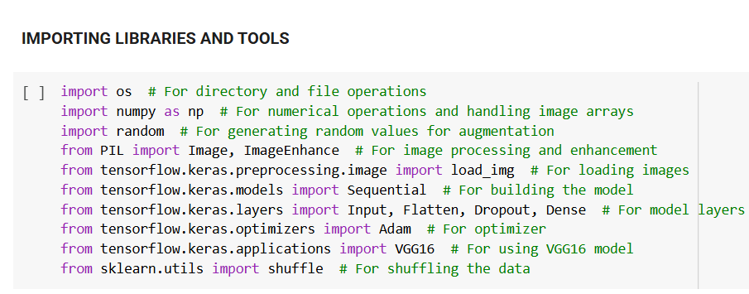
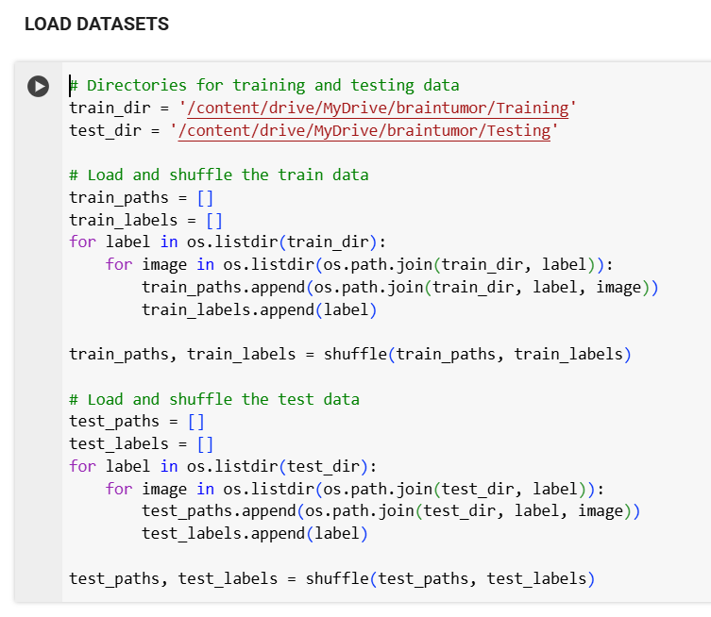
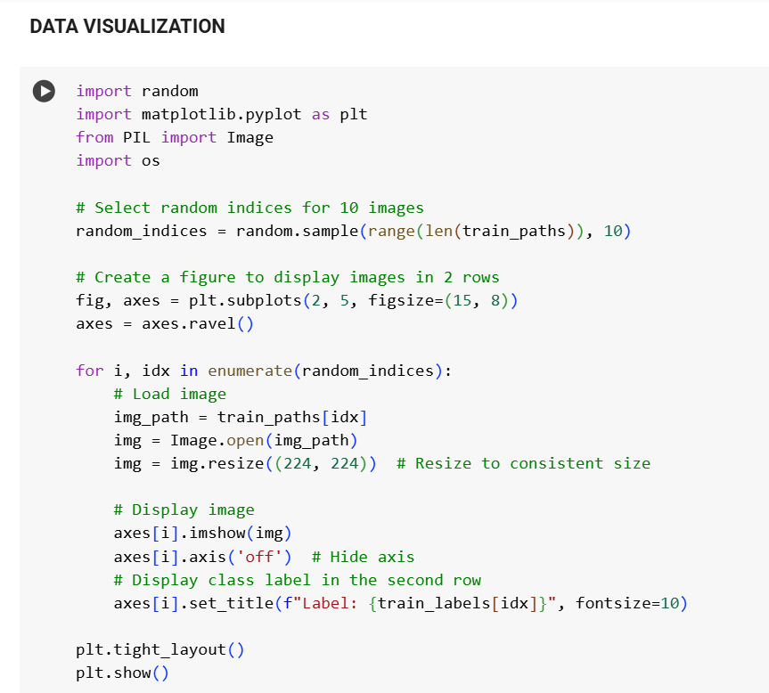
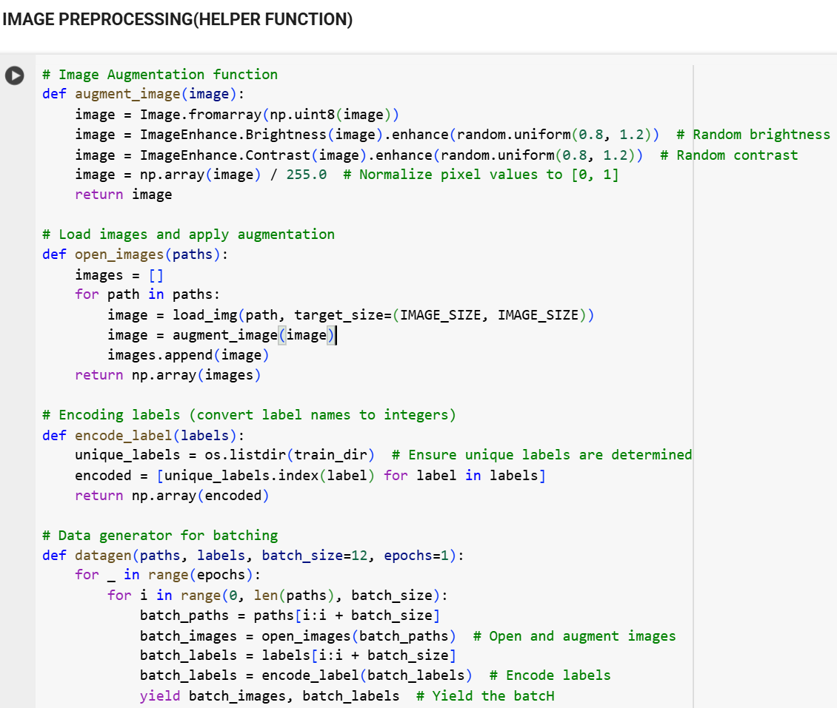
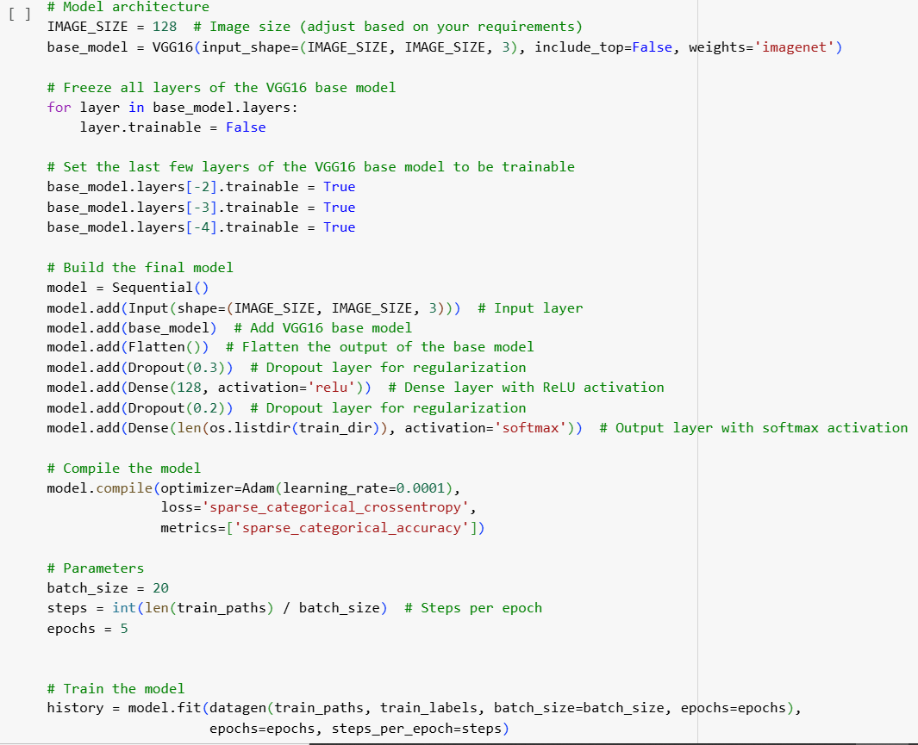

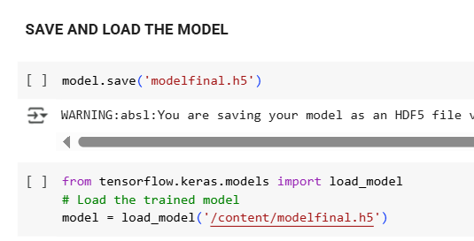

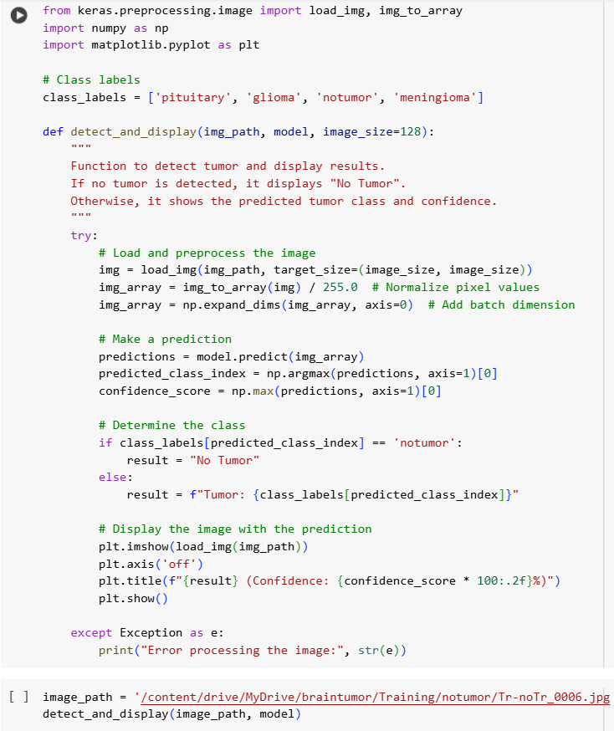

SOURCE CODE-: BACKEND (fig-5.7)
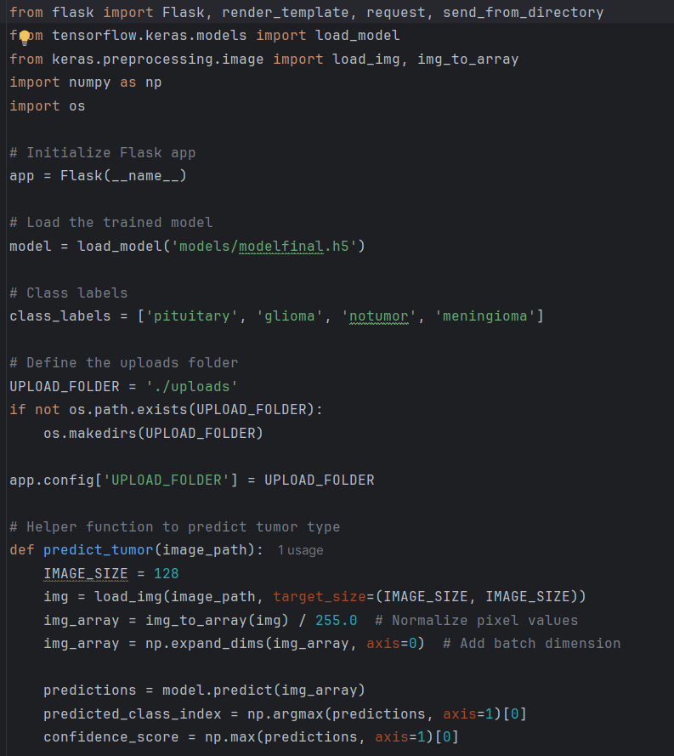
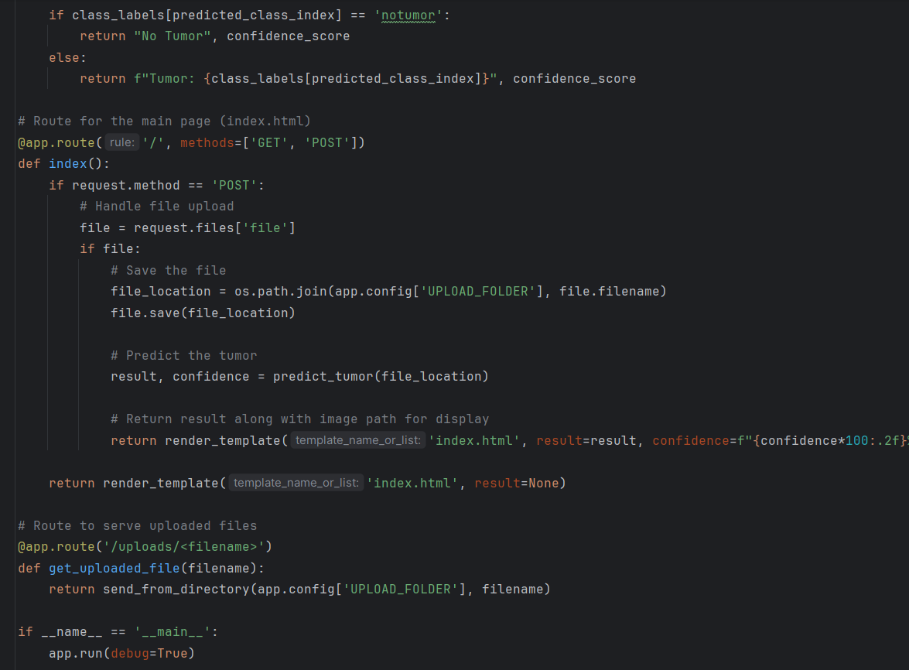
SOURCE CODE-: FRONTEND (fig-5.8)
